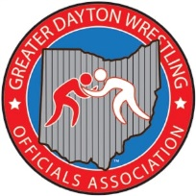GDWOA WEEKLY MINUTES
Date: 11/1/21
Location: Centerville HIGH SCHOOL

Meeting began at 7:00 with president Chaz Deshayes calling the meeting to order.
Present for meeting were 30 members

Secretaries Report –OWOA Clinic reminder and that the association would pay the Clinic fee.
Mention, Stamat Bulugaris was not doing well and that he had to be intubated. Reminder the need for officials for our fund raiser tournament the 2nd week of season. And that we would be taking pictures weekly to update our website.

Treasurers Report –No change in report but at the time was adding dues and monies for shirts and will have a updated total next meeting.
New Business: Chaz informed the association that Kendall needed to step aside from the treasures position for personal reasons and that he has done a excellent job, Chaz stated that we would be taking nominations next week to fulfill that position and that we would be voting the following week after nominations.

Presentation – Presentation was given by Kyle Grilliot and Scott Robinson on Stalling / Fleeing and Stalemates. They did a great job covering different scenarios and situations. They emphasized that we needed to be consistent when calling stalling no matter the period, score or time left in the match.
Announcement: Matthew brought up the need for officials for the MVKWA.
The meeting was adjourned at 8:22
Next meeting is at Stebbins high School and the presenters will be Kyle Stapleton and Chaz Deshayes, the topic will be on Mat Mechanics.

Respectfully submitted
Tony Stapleton - Secretary

